DEALS TO THE HAMPTONS

Visiting the Hamptons? Relax in style in this iconic seaside community, where class, history and entertainment are the standard. Book a trip to The Hamptons via LaGuardia International Airport or John F. Kennedy International Airport. Live it up at 35,000 feet with WiFi, on-demand entertainment, and more on every flight.

(MARKET IMAGE HERE)

Find Deals From These Cities

INSERT FARE GRID FROM / TO Version (if available!)



Top Things To Do in The Hamptons

Whether you’re looking for long days on the Southampton beaches or the upscale boutiques and restaurants of East Hampton, this string of seaside communities is a fabulous place to get away.

* Every year thousands of locals, tourists and daytrippers flock to the Hamptons beaches. Cooper’s Beach is a popular destination with a gorgeous sweep of sand, lifeguards and volleyball nets.
* The Montauk Point Lighthouse is a National Historic Landmark on the easternmost point of Long Island. Built in 1792, it also holds a fascinating museum. The lighthouse is part of Montauk Point State Park, which also has nature trails, playful seals and excellent surf fishing.
* Take a horseback ride at the oldest cattle ranch in the U.S.A. Deep Hollow Ranch offers guided horseback tours of the pristine coastline and woodlands.
* Long Island is often called “the Napa Valley of the East Coast”. Sixty active vineyards dot the area, each producing fantastic local varietals. The Hamptons are also dotted with craft breweries for those more interested in stouts than sauvignons. Montauk Brewing Company, Long Ireland Brewing or Throwback Brewery are all worth a visit.
* If you encounter a rainy day consider visiting the Long Island Aquarium to see penguins, sea lions and sharks up close and personal. You can even snorkel through one of the tropical fish tanks!

Travel Tips and Resources

[Must-Do’s in the Hamptons](https://www.tripadvisor.com/Attractions-g659483-Activities-Hamptons_Long_Island_New_York.html)

[Hamptons Hotels](https://www.tripadvisor.com/Hotels-g659483-Hamptons_Long_Island_New_York-Hotels.html)

[Hamptons Restaurants](http://www.theinfatuation.com/new-york/guides/hamptons)

[Hamptons Shopping Guide](http://hamptons-magazine.com/east-hampton-shopping)

[Hamptons Nightlife and Entertainment](http://hauteliving.com/2012/01/top-5-nightclubs-in-the-hamptons/244681/)

[Hamptons Travel Tips](http://www.travelandleisure.com/articles/insiders-guide-to-the-hamptons)

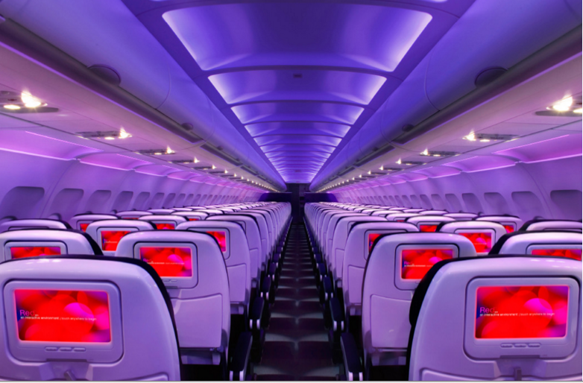

Main Cabin Main Cabin Select First Class

(add links to Cabin Class Pages)

Ready. Set. Fly.

Book your Mood-lit Ride to The Hamptons.

If you’re looking for the best way to get to the Hamptons, book a flight to LaGuardia International Airport (LGA) or John F. Kennedy International Airport (JFK) on Virgin America. Fly with us and experience what it’s like to enjoy comfort and style in the sky. From custom-designed seats to on-demand food ordering and WiFi, our amenities are in a class of their own.

Take a Virtual Tour

Add Terms & Conditions